3× Client Volume Growth for a Houston Personal Injury Firm

SEO

Results that speak for themselves

Key Stats & Results


3x Monthly case volume — client intake tripled

$446K Increase in annual traffic value (Ahrefs)

Behind the transformation

From 12 to 50+ Staff: SEO Growth for a Houston Personal Injury Firm
A fast-growing Houston personal injury law firm partnered with Rankings.io to build a sustainable organic lead pipeline in one of the most competitive legal markets in the United States. Through a comprehensive SEO strategy focused on technical optimization, content authority, and large-scale link building, the firm achieved 259% more search clicks, added $446K in annual traffic value, and ultimately tripled its monthly client intake. The results fueled rapid business growth, helping the firm expand from 12 to more than 50 staff members while consistently generating high-intent personal injury cases through organic search.

FROM CHALLANGES TO SUCCESS


The Challenge
In just four years, this Houston personal injury firm had grown from a staff of 12 to more than 50 employees, making it one of the largest personal injury law offices in the region. But sustaining that growth in Houston's ruthlessly competitive PI market required something the firm's existing digital marketing efforts didn’t deliver: consistent, high-quality organic leads at scale.
The firm's founder understood from the start that steady rainmaking, a continuous flow of qualified new clients, was the lifeblood of a high-volume practice. Unlike corporate law firms with long-term retainer clients, personal injury cases typically resolve within three months to a year, meaning the intake pipeline must remain permanently open and operational.
The problem was structural. The firm had invested in both in-house digital marketing and an external website and content vendor, but neither generated meaningful traction in search rankings. It created content, but it wasn't winning the competitive keyword battles that drive real lead volume.
A further complication: The firm operated from a suburban location and Google's local ranking algorithm gives a measurable advantage to downtown-based offices. Competing against city-center firms for the most valuable local personal injury keywords required a level of domain authority the site didn't yet have.
When a preliminary Rankings.io assessment of the existing SEO strategy produced immediate gains, higher than anything the firm's team had seen before, the decision to commission a full SEO overhaul became straightforward.
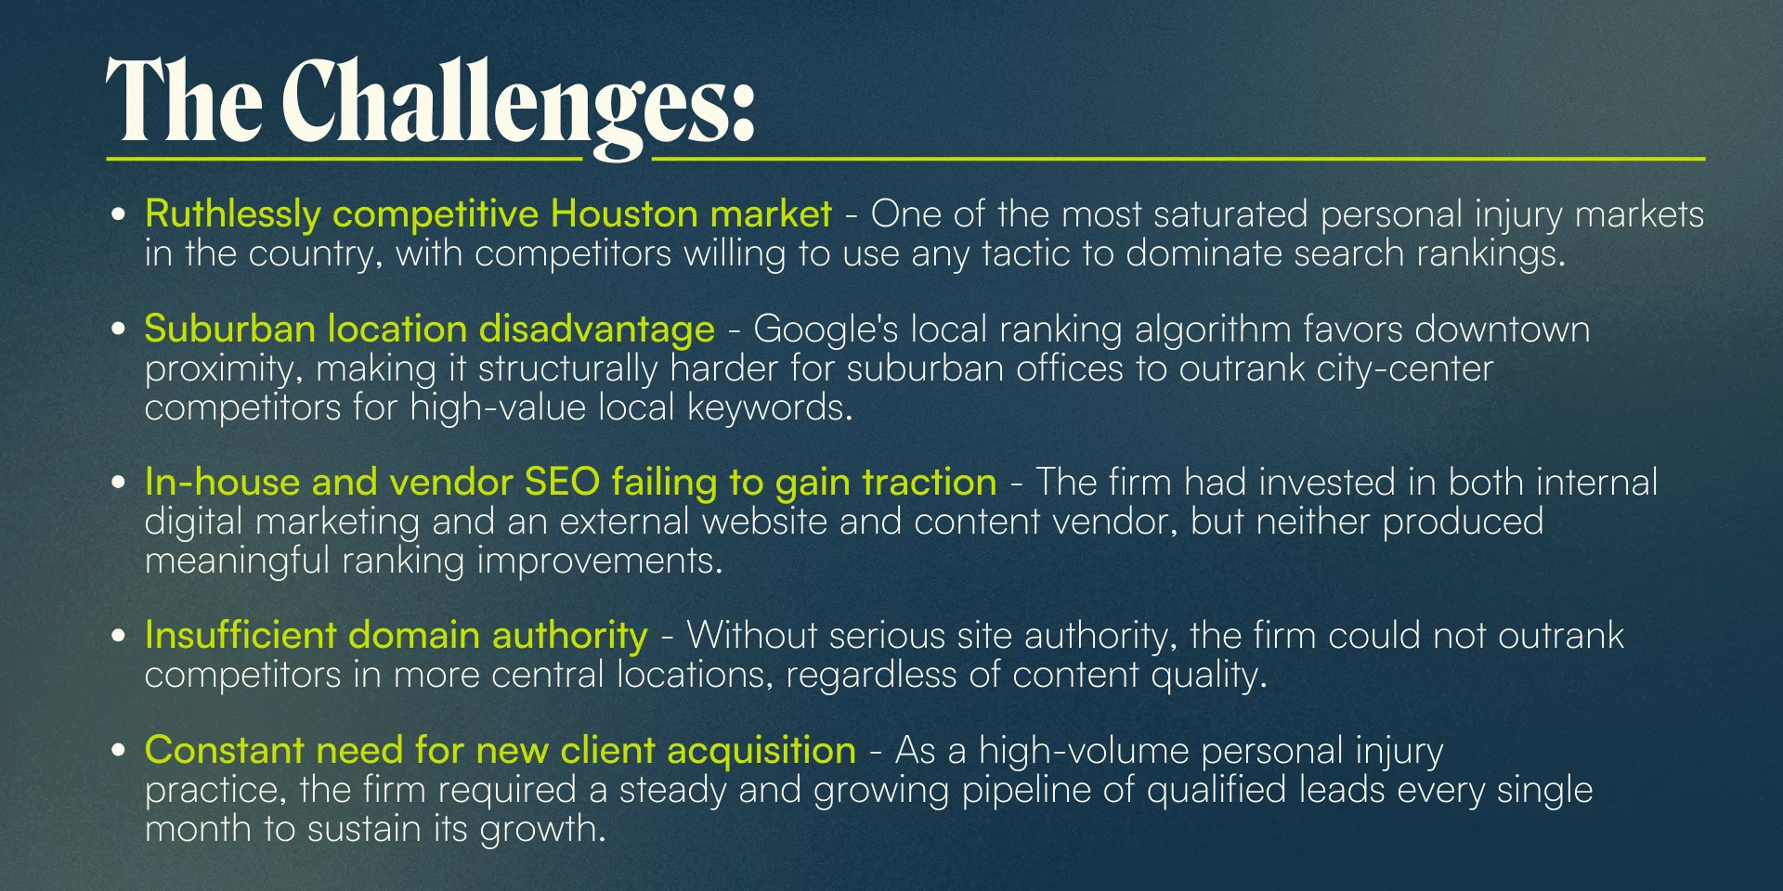



How We Did It: The Strategy
Rankings.io deployed a comprehensive, ethics-first SEO strategy, entirely Google-approved, with no shortcuts or black-hat tactics. We tailored the approach specifically to the firm's competitive landscape, suburban location challenge, and long-term growth ambitions.

SEO Strategy for a Houston Personal Injury Firm
Rather than applying a standard playbook, Rankings.io built a custom, multi-layered strategy designed to overcome the firm's specific structural disadvantages while compounding authority over time.

1. Comprehensive SEO Audit
Rankings.io began with a deep-dive technical audit of the site, identifying the specific issues suppressing rankings, from crawlability problems and content structure to citation inconsistencies and link gaps. The audit informed every subsequent action.

2. Content Re-Optimization & Research-Driven Content Strategy
Using the audit findings, Rankings.io re-optimized the site's existing content and structure to improve crawlability, topical relevance, and alignment with searcher intent. We then developed a research-driven content marketing strategy, including a social promotion plan to amplify the firm's content assets across its digital channels.

3. Citation Cleanup & Local SEO
Rankings.io cleaned up the firm's entire citation profile, ensuring a perfectly consistent name, address, and phone number across every directory, listing, and web property. This NAP consistency is a foundational local map ranking signal and correcting inconsistencies produced measurable improvements in local pack visibility.

4. Large-Scale Link Building & Scholarship Campaign
To overcome the geographic authority gap, Rankings.io executed a large-scale link-building campaign combining one-to-one outreach to industry professionals with the creation of a scholarship program designed to earn highly trusted .edu backlinks from post-secondary institutions.
These were not mass-submission or low-quality directory links. Earning .edu and high-authority backlinks required building genuine relationships, and Rankings.io invested the time to do it properly. The resulting link profile directly contributed to the firm's ability to outrank downtown competitors despite its suburban location.



Before & After
Within months of the initial campaign, the firm's phone volume surged. That growth continued to accelerate over the following years, the numbers told the story of a practice transformed.
The firm's team expanded by another 180% in the years following the initial engagement. The SEO investment, described by the firm's founder as the best ROI of any marketing dollar spent, continues to drive a growing volume of web inquiries, phone calls, and cases.

Key Wins
- 47% increase in inbound phone calls, alongside a significant rise in online contact form submissions
- Firm grew from 12 to 50+ staff — team expanded 180% in the years following the engagement
- 188% increase in search impressions
- 259% increase in search clicks, demonstrating strong alignment between content and search intent
- 126% increase in new website users year-over-year
- 2,346 links earned, strengthening rankings for highly competitive phrases
- $446,000 increase in annual traffic value according to Ahrefs, reflecting the compounding commercial impact of the rankings earned

Ready to Grow Your Firm?
This case study shows how a long-term, ethical SEO partnership can compound over years, tripling case volume, scaling a firm's headcount, and generating traffic value that dwarfs any paid advertising spend.
At Rankings.io, we specialize exclusively in SEO for lawyers. We combine technical expertise, content authority, and advanced link-building strategies tailored specifically to personal injury firms in competitive markets.
The best ROI of any marketing dollar you spend. Let's make it rain.

